**Intelligent Wireless Energy Metering and Safety Control System for Enhanced Power Consumption Management**

**AIM&OBJECTIVE**

* To eliminate the manual process of meter reading by introducing a smart energy meter system. This automation will enable employees to read energy and water meters remotely, reducing the need for physical visits to each household.
* To Establish a real-time monitoring system using IoT to track energy meter units.

**ABSTRACT:**

This project is designed with microcontroller, energy meter, Signal conditioning unit, potential transformer, temperature sensor and driver and relay circuit, IoT module. we are going to use AC source from electricity board. In the IoT server, we can monitor whether the consumer consuming electricity board energy and control the load through Internet of Things. Based on our government system, first 100 unit of energy is not calculated by energy meter, which is used to calculate the electricity consumed unit in the consumer node. So that we can know, the consumed energy in the consumer node exactly with help of LCD displays. The microcontroller analyses the signal and accordingly it sends signal to the LCD display. The wireless energy meter monitoring system aims to minimize these difficulties by providing energy meter monitoring through wireless medium. Power consumed by consumer in the home side module is monitored by Electricity Board through wireless technology using IoT. The consumed energy in the consumer node exactly with help of IoT module.The temperature sensor is used to detect the fire accident, and trip the main supply automatically and updated to cloud server.

**CHAPTER –1**

**INTRODUCTION**

In the realm of modern technology, the convergence of microcontrollers, IoT modules, and smart sensing devices has revolutionized various aspects of our lives, particularly in the domain of energy management and consumption monitoring. This project represents a pioneering effort in leveraging these advancements to develop a sophisticated Wireless Energy Meter Monitoring System.

At its core, the system integrates a plethora of components including microcontrollers, energy meters, signal conditioning units, potential transformers, temperature sensors, drivers, relay circuits, and IoT modules. These elements collectively orchestrate a seamless orchestration of energy monitoring and control functionalities.

Central to the system's architecture is its ability to interface with the AC power source provided by the electricity board. Through intricate signal conditioning and analysis, the microcontroller accurately measures and interprets the energy consumption patterns of the consumer node. Importantly, the system adheres to government regulations, exempting the initial 100 units of energy from metering, thus ensuring fairness and accuracy in energy billing.

The IoT module acts as the linchpin of connectivity, facilitating real-time monitoring and control of energy consumption remotely. This allows for unprecedented levels of transparency and control over energy usage, empowering users to make informed decisions to optimize efficiency and reduce costs.

Moreover, the incorporation of temperature sensors adds an additional layer of safety and security to the system. In the event of a fire accident, the sensors promptly detect abnormal temperature spikes, triggering an automatic shutdown of the main power supply. Furthermore, pertinent data regarding such incidents is seamlessly transmitted to cloud servers for archival and analysis purposes.

In essence, this Wireless Energy Meter Monitoring System epitomizes the marriage of cutting-edge technology and practical utility. By amalgamating advanced sensing, computing, and communication capabilities, it promises to revolutionize the landscape of energy management, ushering in an era of unprecedented efficiency, safety, and control.

**CHAPTER – 2**

**LITERATURE SURVEY**

**1. H. G. Rodney Tan, C. H. Lee and V. H. Mork, “Automatic power meter reading systems using GSM network”, IEEE, 8th International Power Engineering Conference, pp. 465-469, 2017.**

Owing to high electricity cost these days it becomes necessary for the consumer to know as to how much electricity is consumed to control electricity bill within his budget. In this proposed system, the consumer will get his energy consumption data on real time basis on a LCD display. The same data is sent through GSM modem to the electricity department via SMS. Arduino is interfaced to the energy meter to get the Watt Hour pulses. The Arduino then processes these pulses according the program written in it, to calculate the units consumed and cost involved. Further it gives command to the SIM loaded GSM modem for sending the data to the customer/consumer via SMS. Further this work can be enhanced to control the electrical appliances remotely via SMS. Also it can be used to monitor the power consumption or any other factor like pressure, temperature etc. with appropriate changes.

**2. Ashna K, Sudhish N Gorgre, “GSM based automatic energy meter reading system with instant billing”, IEEE International conference held at Kottayam, pp. 65-72, 2018.**

The technology of e-metering (Electronic Metering) has gone through rapid technological advancements and there is increased demand for a reliable and efficient Automatic Meter Reading (AMR) system. This paper presents the design of a simple low cost wireless GSM energy meter and its associated web interface, for automating billing and managing the collected data globally. The proposed system replaces traditional meter reading methods and enables remote access of existing energy meter by the energy provider. Also they can monitor the meter readings regularly without the person visiting each house. A GSM based wireless communication module is integrated with electronic energy meter of each entity to have remote access over the usage of electricity. A PC with a GSM receiver at the other end, which contains the database acts as the billing point. Live meter reading from the GSM enabled energy meter is sent back to this billing point periodically and these details are updated in a central database. A new interactive, user friendly graphical user interface is developed using Microsoft visual studio .NET framework and C#. With proper authentication, users can access the developed web page details from anywhere in the world. The complete monthly usage and due bill is messaged back to the customer after processing these data.

**3. SubhashisMaitra, “Embedded Energy Meter- A new concept to measure the energy consumed by a consumer and to pay the bill”, Power System Technology and IEEE Power India Conference, 2018.**

In this paper, a new concept of energy meter will be discussed, where maximum demand of energy of a consumer will be indicated in the meter used by the consumer. After exceeding the maximum demand, the meter and hence the connection will automatically be disconnected by an embedded system inserted in the meter itself. According to the maximum demand, the consumer will purchase a cash-card of amount depending on the consumption of energy and after the full consumption, the consumer again has to purchase another cash-card or recharge the same and thus the hassle related to go to the billing office, to stand in a long queue and to submit the bill, can be avoided. Also this system helps to eliminate the draw backs of billing management system, such as to take the reading from the meter, to create the bill, to print the bill, to send the bill to the proper address and to collect the amount for the bill. Hence this system can effectively reduce the man power required to a great extent. Also a new concept of a distributor has been dealt here which is used to disconnect a line if the energy consumption per day of a consumer greatly exceeds a pre-demand energy consumption per day. With the help of this system electric supply authority can detect a power hacker also.

**4. A. Arif, Muhannad AI-Hussain, Nawaf AI-Mutairi, “Experimental study and Design of smart Energy Meter for the smart Grid” , IEEE International Conference, pp 978-1-4673-6374, 2018**.

The demand for energy is increasing as a result of the growth in both population and industrial development. To improve the energy efficiency, consumers need to be more aware of their energy consumption. In recent years, utilities have started developing new electric energy meters which are known as smart meters. A smart meter is a digital energy meter that measures the consumption of electrical energy and provides other additional information as compared to the traditional energy meter. The aim is to provide the consumer and supplier an easy way to monitor the energy. Smart meters are considered a key component of the smart grid as these will allow more interactivity between the consumers and the provider. Smart meters will enable two-way and real-time communication between the consumers and the provider. Considering the increase of electricity demand in Saudi Arabia, smart meters can decrease the overall energy consumption. This paper presents the development of a GSM and ZigBee based smart meter. This meter can measure the energy and send the information to the service provider, who can store this information and notify the consumer through SMS messages or through the internet.

**5. Tian yew lim and tat Waichan,“Experimenting remote kilowatthour meter reading through low voltage power lines at dense housing estates”, IEEE Transactions on Power Delivery vol. 17, Issue 3, pp. 708-711, Jul 2020.**

Deregulation, freer customer choice, and open market competition are occurring in the energy supply market. These changes necessitate the automating of kilowatthour (kWh) reading for most energy suppliers. Power lines are readily available and making the full use of them is most desirable to the energy suppliers. However, power line is a hostile communication environment and it is imperative to know its characteristics. This paper describes a prototype automated meter reading system using the power lines and frequency shift keying modulation operating in the EN 50065-1 A Band. Its performance and reliability aspects are also presented.

**CHAPTER – 3**

**SYSTEM DESIGN**

**3.1 EXISTING SYSTEM**

Our existing electricity billing system has major drawbacks due to manual work. In our existing system services of power companies are also not good and perfect. Customers are also not satisfied with the current system because many times they have complaint about to statistical error in monthly bills. Thus, we are trying to represent the idea about minimization of error, reduce the paperwork, human dependency in the system. The user go the EB office to manually pay his bills. The readings are taken using the analogue or digital meter present in the customer house. The readings area taken using an employee workings at the Eb office. The service provider for energy still uses conventional methods for getting the energy consumed by individual customer. The billing process of electricity consumption which we are using at present is very long process and requires a lot of manpower. The electrical meters are installed on consumer premises and the consumption information is collected by meter readers on their fortnightly or monthly visits to the premises. Hiring of a number of meter readers by utilities companies and providing means of transportation to them is an expensive burden on the companies budgets. Dissatisfaction of some customer who consider meter-readers entrance to their homes as some sort of invasion of their privacy.

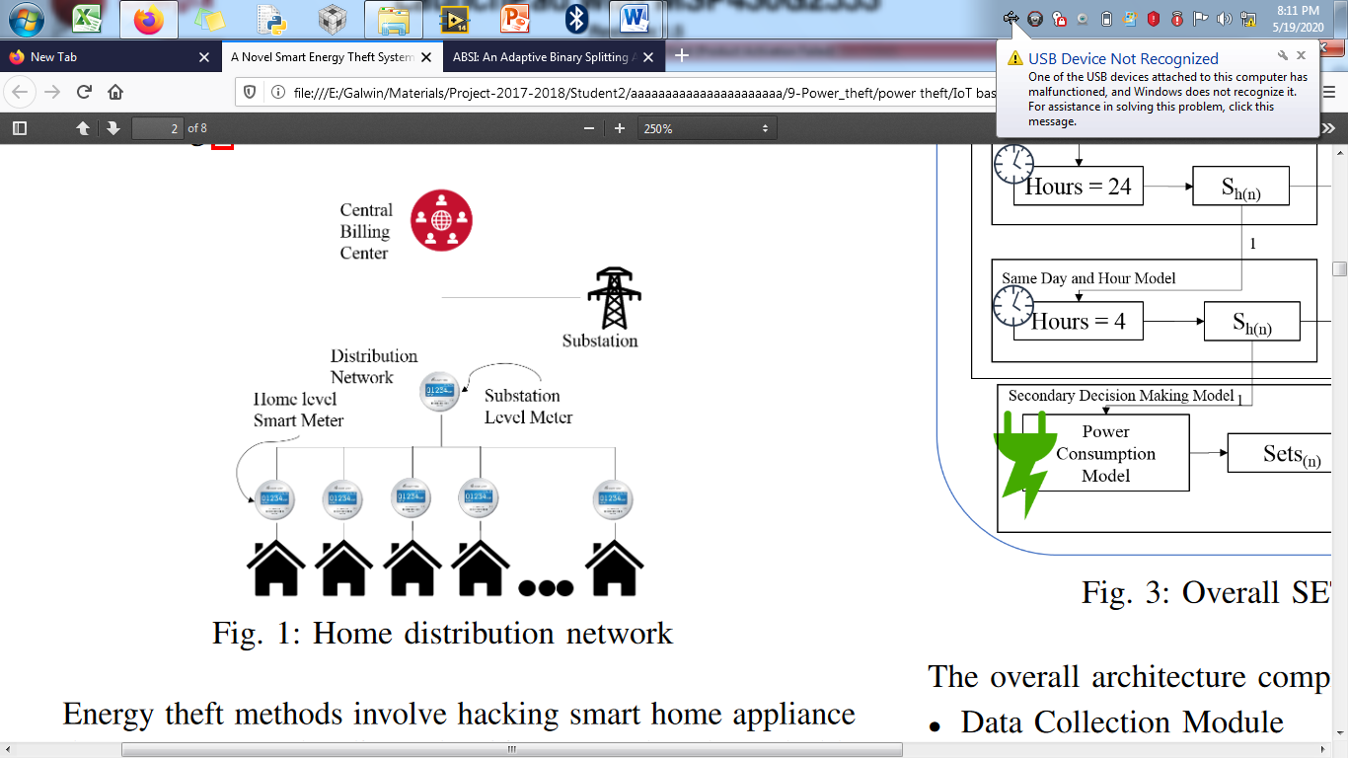

**Fig 3.1 Block Diagram of Existing System**

**3.2 DRAWBACKS OF EXISTING SYSTEMS**

The existing system involves errors present in the meter reading which are committed due to human mistakes. Since all data here are taken manually dates can be easily manipulated by third parties who affect the EB office and the customer. The amount of workforce involved in this prevailing EB system is too large as the EB people have to visit many areas at roughly the same date. This system takes a lot of time to go personally to customer’s house and take the readings. In conventional meter system people try to manipulate meter readings by adopting various corrupt practices such as current reversal or CT reverse tampers, partial earth fault condition, bypass meter, magnetic interference etc. There is a stark amount of revenue loss being incurred by our country.

* 1. **PROPOSED SYSTEM**

The proposed system integrates a microcontroller, energy meter, Signal conditioning unit, potential transformer, temperature sensor, driver and relay circuit, and an IoT module. The system is designed to utilize AC power from the electricity board, ensuring compatibility with the existing infrastructure. The energy meter accurately measures the energy consumption of the consumer node, excluding the first 100 units of energy consumption as per government regulations. Utilizing wireless technology, the system enables real-time monitoring of energy consumption by the Electricity Board, facilitating efficient management and billing processes. The IoT module enables remote monitoring and control of energy consumption and loads, providing convenience and flexibility through Internet connectivity. A temperature sensor detects fire accidents, triggering an automatic shutdown of the main power supply and transmitting information to the cloud server for analysis. The potential transformer measures input voltage accurately, triggering alerts in case of abnormalities to ensure the safety of connected loads and prevent damage.

**BLOCK DIAGRAM**

**CONSUMER UNIT:**

POWER SUPPLY FOR ALL UNIT

D MICRO CONTROLLER

(PIC16F877A)

IOT MODULE

LCD DISPLAY

TEMPERATURE SENSOR

AC(230 V)

ENERGY METER

PT

DRIVER

RELAY

LOAD

OPTO -COUPLER

**CHAPTER –4**

**HARDWARE DESCRIPTION**

4.1 POWER SUPPLY

Power supply is a reference to a source of [electrical power](http://en.wikipedia.org/wiki/Electrical_power). A device or system that supplies [electrical](http://en.wikipedia.org/wiki/Electrical) or other types of [energy](http://en.wikipedia.org/wiki/Energy) to an output [load](http://en.wikipedia.org/wiki/External_electric_load) or group of loads is called a power supply unit or PSU. The term is most commonly applied to electrical energy supplies, less often to mechanical ones, and rarely to others.

Power supplies for electronic devices can be broadly divided into linear and switching power supplies. The linear supply is a relatively simple design that becomes increasingly bulky and heavy for high current devices; voltage regulation in a linear supply can result in low efficiency. A switched-mode supply of the same rating as a linear supply will be smaller, is usually more efficient, but will be more complex.

Linear Power supply:

An [AC](http://en.wikipedia.org/wiki/Alternating_current) powered linear power supply usually uses a [transformer](http://en.wikipedia.org/wiki/Transformer) to convert the voltage from the wall outlet (mains) to a different, usually a lower voltage. If it is used to produce [DC](http://en.wikipedia.org/wiki/Direct_current), a [rectifier](http://en.wikipedia.org/wiki/Rectifier) is used. A [capacitor](http://en.wikipedia.org/wiki/Capacitor) is used to smooth the pulsating current from the rectifier. Some small periodic deviations from smooth direct current will remain, which is known as [ripple](http://en.wikipedia.org/wiki/Ripple_(electrical)). These pulsations occur at a frequency related to the AC [power frequency](http://en.wikipedia.org/wiki/Utility_frequency) (for example, a multiple of 50 or 60 Hz).

The voltage produced by an unregulated power supply will vary depending on the load and on variations in the AC supply voltage. For critical electronics applications a [linear regulator](http://en.wikipedia.org/wiki/Linear_regulator) will be used to stabilize and adjust the voltage. This regulator will also greatly reduce the ripple and noise in the output direct current. Linear regulators often provide current limiting, protecting the power supply and attached circuit from over current.

Adjustable linear power supplies are common laboratory and service shop test equipment, allowing the output voltage to be set over a wide range. For example, a bench power supply used by circuit designers may be adjustable up to 30 volts and up to 5 amperes output. Some can be driven by an external signal, for example, for applications requiring a pulsed output.

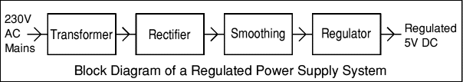

Transformer:



Transformers convert AC electricity from one voltage to another with little loss of power. Transformers work only with AC and this is one of the reasons why mains electricity is AC.

Step-up transformers increase voltage, step-down transformers reduce voltage. Most power supplies use a step-down transformer to reduce the dangerously high mains voltage (230V in UK) to a safer low voltage. The input coil is called the primary and the output coil is called the secondary. There is no electrical connection between the two coils; instead, they are linked by an alternating magnetic field created in the soft-iron core of the transformer. The two lines in the middle of the circuit symbol represent the core. Transformers waste very little power so the power out is (almost) equal to the power in. Note that as voltage is stepped down current is stepped up. The ratio of the number of turns on each coil, called the turn’s ratio, determines the ratio of the voltages. A step-down transformer has a large number of turns on its primary (input) coil which is connected to the high voltage mains supply, and a small number of turns on its secondary (output) coil to give a low output voltage. Turns ratio=Vp/Vs=Nn/Ns and Power out=Power in

Vs*Is=Vp * Ip

|  |  |  |
| --- | --- | --- |
| Vp = primary (input) voltage Np = number of turns on primary coil Ip  = primary (input) current |  | Vs = secondary (output) voltage Ns = number of turns on secondary coil Is = secondary (output) current |

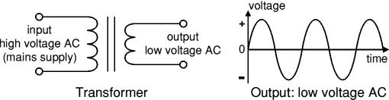

The low voltage AC output is suitable for lamps, heaters and special AC motors. It is not suitable for electronic circuits unless they include a rectifier and a smoothing capacitor.

**Rectifier:**

There are several ways of connecting diodes to make a rectifier to convert AC to DC. The [bridge rectifier](http://www.kpsec.freeuk.com/powersup.htm#bridgerectifier) is the most important and it produces full-wave varying DC. A full-wave rectifier can also be made from just two diodes if a centre-tap transformer is used, but this method is rarely used now that diodes are cheaper. A [single diode](http://www.kpsec.freeuk.com/powersup.htm#singlediode) can be used as a rectifier but it only uses the positive (+) parts of the AC wave to produce half-wave varying DC.

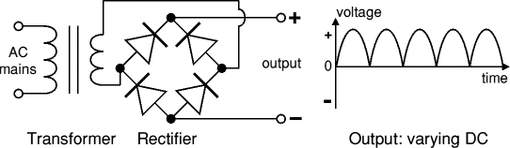

The varying DC output is suitable for lamps, heaters and standard motors. It is not suitable for electronic circuits unless they include a smoothing capacitor.

**Bridge rectifier:**

A bridge rectifier can be made using four individual diodes, but it is also available in special packages containing the four diodes required. It is called a full-wave rectifier because it uses the entire AC wave (both positive and negative sections). 1.4V is used up in the bridge rectifier because each diode uses 0.7V when conducting and there are always two diodes conducting, as shown in the diagram below. Bridge rectifiers are rated by the maximum current they can pass and the maximum reverse voltage they can withstand (this must be at least three times the supply [RMS](http://www.kpsec.freeuk.com/acdc.htm#rms) voltage so the rectifier can withstand the peak voltages). Please see the [Diodes](http://www.kpsec.freeuk.com/components/diode.htm#bridge) page for more details, including pictures of ridge rectifiers.



Alternate pairs of diodes conduct, changing over the connections so the alternating directions of AC are converted to the one direction of DC.

Output: full-wave varying DC: (using the entire AC wave):

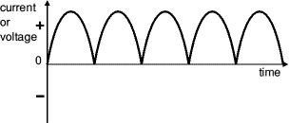

**Single diode rectifier:**

A single diode can be used as a rectifier but this produces half-wave varying DC which has gaps when the AC is negative. It is hard to smooth this sufficiently well to supply electronic circuits unless they require a very small current so the smoothing capacitor does not significantly discharge during the gaps. Please see the [Diodes](http://www.kpsec.freeuk.com/components/diode.htm#rectifier) page for some examples of rectifier diodes.

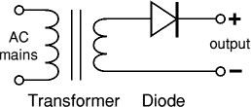

Output: half-wave varying DC (using only half the AC wave):

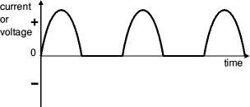

**Smoothing:**

Smoothing is performed by a large value electrolytic capacitor connected across the DC supply to act as a reservoir, supplying current to the output when the varying DC voltage from the rectifier is falling. The diagram shows the unsmoothed varying DC (dotted line) and the smoothed DC (solid line). The capacitor charges quickly near the peak of the varying DC, and then discharges as it supplies current to the output.

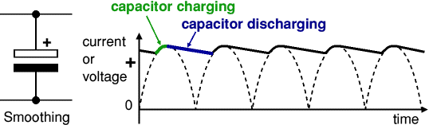

Note that smoothing significantly increases the average DC voltage to almost the peak value (1.4 × [RMS](http://www.kpsec.freeuk.com/acdc.htm#rms) value). For example 6V RMS AC is rectified to full wave DC of about 4.6V RMS (1.4V is lost in the bridge rectifier), with smoothing this increases to almost the peak value giving 1.4 × 4.6 = 6.4V smooth DC.

Smoothing is not perfect due to the capacitor voltage falling a little as it discharges, giving a small ripple voltage. For many circuits a ripple which is 10% of the supply voltage is satisfactory and the equation below gives the required value for the smoothing capacitor. A larger capacitor will give fewer ripples. The capacitor value must be doubled when smoothing half-wave DC.

Smoothing Capacitor for 10% ripple, C=5*10/vs.*f

C = smoothing capacitance in farads (F)

Io = output current from the supply in amps (A)

Vs = supply voltage in volts (V), this is the peak value of the unsmoothed DC

f    = frequency of the AC supply in hertz (Hz), 50Hz in the UK.

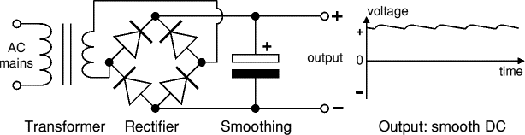

The smooth DC output has a small ripple. It is suitable for most electronic circuits.

Regulator:

Voltage regulator ICs are available with fixed (typically 5, 12 and 15V) or variable output voltages. They are also rated by the maximum current they can pass. Negative voltage regulators are available, mainly for use in dual supplies. Most regulators include some automatic protection from excessive current ('overload protection') and overheating ('thermal protection').

The LM78XX series of three terminal regulators is available with several fixed output voltages making them useful in a wide range of applications. One of these is local on card regulation, eliminating the distribution problems associated with single point regulation. The voltages available allow these regulators to be used in logic systems, instrumentation, HiFi, and other solid state electronic equipment. Although designed primarily as fixed voltage regulators these devices can be used with external components to obtain adjustable voltages and current. Many of the fixed voltage regulator ICs has 3 leads and look like power transistors, such as the 7805 +5V 1A regulator shown on the right. They include a hole for attaching a [heat sink](http://www.kpsec.freeuk.com/components/heatsink.htm) if necessary.

* Positive regulator
* input pin
* ground pin
* output pin

It regulates the positive voltage

* Negative regulator
* ground pin
* input pin
* output pin

It regulates the negative voltage

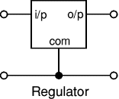

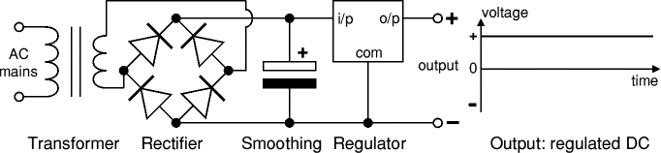

The regulated DC output is very smooth with no ripple. It is suitable for all electronic circuits.

**4.2 ELECTRICITY METER**

An **electric meter** or **energy meter** is a device that measures the amount of [electrical](http://en.wikipedia.org/wiki/Electricity) [energy](http://en.wikipedia.org/wiki/Energy) consumed by a [residence](http://en.wikipedia.org/wiki/House), [business](http://en.wikipedia.org/wiki/Business), or an electrically powered device. Electric meters are typically calibrated in billing units, the most common one being the [kilowatt hour](http://en.wikipedia.org/wiki/Kilowatt_hour). Periodic readings of electric meters establish billing cycles and energy used during a cycle. In settings when energy savings during certain periods are desired, meters may measure demand, the maximum use of power in some interval. In some areas, the electric rates are higher during certain times of day, to encourage reduction in use. Also, in some area’s meters have relays to turn off nonessential equipment.

**4.2.1 ELECTROMEHCANICAL INDUCTION WATT-HOUR METER**

The most common type of electricity meter is the [electromechanical](http://en.wikipedia.org/wiki/Electromechanical) [induction](http://en.wikipedia.org/wiki/Electromagnetic_induction) watt-hour meter.

The metallic disc is acted upon by two [coils](http://en.wikipedia.org/wiki/Induction_coil). One coil is connected in such a way that it produces a fluxing proportion to the [voltage](http://en.wikipedia.org/wiki/Voltage) and the other produces a magnetic flux in proportion to the [current](http://en.wikipedia.org/wiki/Electric_current). The field of the voltage coil is delayed by 90 degrees using a lag coil.[[16]](http://en.wikipedia.org/wiki/Electricity_meter#cite_note-15) This produces [eddy currents](http://en.wikipedia.org/wiki/Eddy_current) in the disc and the effect is such that a [force](http://en.wikipedia.org/wiki/Force) is exerted on the disc in proportion to the product of the instantaneous current and voltage. A permanent exerts an opposing force proportional to the [speed of rotation](http://en.wikipedia.org/wiki/Angular_velocity) of the disc. The equilibrium between these two opposing forces results in the disc rotating at a speed [proportional](http://en.wikipedia.org/wiki/Proportionality_(mathematics)) to the power being used. The disc drives a register mechanism which [integrates](http://en.wikipedia.org/wiki/Integral) the speed of the disc over time by counting revolutions, much like the [odometer](http://en.wikipedia.org/wiki/Odometer) in a car, in order to render a measurement of the total energy used over a period of time.

[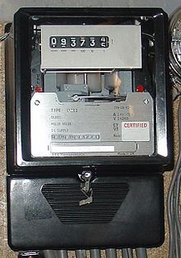](http://en.wikipedia.org/wiki/File:ThreePhaseElectricityMeter.jpg)

**FIG 4.2. ELECTROMECHANICAL INDECTION WATT-HOUR METER.**

The amount of energy represented by one revolution of the disc is denoted by the symbol *Kh* which is given in units of watt-hours per revolution. The value 7.2 is commonly seen. Using the value of *Kh*, one can determine their power consumption at any given time by timing the disc with a stopwatch. If the time in seconds taken by the disc to complete one revolution is *t*, then the power in watts is P = {{ 3600 \cdot Kh } \over t}.

In an induction type meter, creep is a phenomenon that can adversely affect accuracy, that occurs when the meter disc rotates continuously with potential applied and the load terminals open circuited. A test for error due to creep is called a creep test.

Two standards govern meter accuracy, [ANSI C12.20](http://en.wikipedia.org/wiki/ANSI_C12.20) for North America and IEC 62053.

**4.2.2 ELECTRONNIC METER**

Electronic meters display the energy used on an [LCD](http://en.wikipedia.org/wiki/LCD) or LED display and can also transmit readings to remote places. In addition to measuring energy used, electronic meters can also record other parameters of the load and supply such as maximum demand, [power factor](http://en.wikipedia.org/wiki/Power_factor) and [reactive power](http://en.wikipedia.org/wiki/Reactive_power) used etc. They can also support time-of-day billing,

**[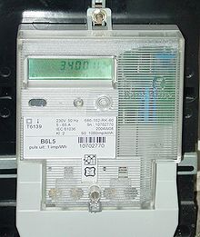](http://en.wikipedia.org/wiki/File:Solid-state-electricity-meter.jpg)**

[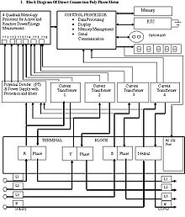](http://en.wikipedia.org/wiki/File:Block_Diagram.JPG)

**Fig 4.3 electronic meter**

As in the block diagram, the meter has a power supply, a metering engine, a processing and communication engine (i.e. a [microcontroller](http://en.wikipedia.org/wiki/Microcontroller)), and other add-on modules such as RTC, LCD display, communication ports/modules and so on.

The metering engine is given the voltage and current inputs and has a voltage reference, samplers and quantisers followed by an ADC section to yield the digitised equivalents of all the inputs. These inputs are then processed using a Digital Signal Processor to calculate the various metering parameters such as powers, energies etc.

The largest source of long-term errors in the meter is drift in the preamp, followed by the precision of the voltage reference. Both of these vary with temperature as well, and vary wildly because most meters are outdoors. Characterizing and compensating for these is a major part of meter design.

The processing and communication section has the responsibility of calculating the various derived quantities from the digital values generated by the metering engine. This also has the responsibility of communication using various protocols and interface with other addon modules connected as slaves to it.

RTC and other add-on modules are attached as slaves to the processing and communication section for various input/output functions. On a modern meter most if not all of this will be implemented inside the microprocessor, such as the Real Time Clock (RTC), LCD controller, temperature sensor, memory and analog to digital converters.

**4.2.3 SMART METERS**

Smart meters go a step further than simple AMR ([automatic meter reading](http://en.wikipedia.org/wiki/Automatic_meter_reading)). They offer additional functionality including a real-time or near real-time reads, [power outage](http://en.wikipedia.org/wiki/Power_outage) notification, and power quality monitoring. They allow price setting agencies to introduce different prices for consumption based on the time of day and the season.

Another type of smart meter uses [nonintrusive load monitoring](http://en.wikipedia.org/wiki/Nonintrusive_load_monitoring) to automatically determine the number and type of appliances in a residence, how much energy each uses and when. This meter is used by electric utilities to do surveys of energy use. It eliminates the need to put timers on all of the appliances in a house to determine how much energy each uses.

**4.2.4 TAMPERING AND SECURITY**

Meters can be manipulated to make them under-register, effectively allowing power use without paying for it. This theft or fraud can be dangerous as well as dishonest.

Power companies often install remote-reporting meters specifically to enable remote detection of tampering, and specifically to discover energy theft. The change to smart power meters is useful to stop energy theft.

**4.3 OPTOCOUPLER:**

There are many situations where signals and data need to be transferred from one subsystem to another within a piece of electronics equipment, or from one piece of equipment to another, without making a direct .ohmic. Electrical connection. Often this is because the source and destination are (or may be at times) at very different voltage levels, like a microprocessor which is operating from 5V DC but being used to control a triac which is switching 240V AC. In such situations the link between the two must be an isolated one, to protect the Microprocessor from overvoltage damage.

Relays can of course provide this kind of isolation, but even small relays tend to be fairly bulky compared with ICs and many of today’s other miniature circuit components. Because they.re electro-mechanical, relays are also not as reliable and only capable of relatively low speed operation.

Where small size, higher speed and greater reliability are important, a much better alternative is to use an optocouplers. These use a beam of light to transmit the signals or data across an electrical barrier, and achieve excellent isolation.

Optocouplers typically come in a small 6-pin or 8-pin IC package, but are essentially a combination of two distinct devices: an optical transmitter, typically a gallium arsenide LED and an optical receiver such as a phototransistor or light-triggered diac. The two are separated by a transparent barrier which blocks any electrical current flow between the two, but does allow the passage of light.

Usually the electrical connections to the LED section are brought out to the pins on one side of the package and those for the phototransistor or diac to the other side, to physically separate them as much as possible.

This usually allows optocouplers to withstand voltages of anywhere between 500V and 7500V between input and output. Optocouplers are essentially digital or switching devices, so they.re best for transferring either on-off control signals or digital data. Analog signals can be transferred by means of frequency or pulse-width modulation.

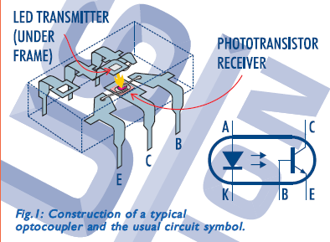

**Fig.4.4 optocoupler**

**CURRENT SENSOR (CT SENSOR)**

**GENERAL DESCRIPTION**

The current sensor can measure DC current or high AC mains current and is still isolated from the measuring part due to integrated hall sensor. The analog output voltage is proportional to the current measured on the sensing terminals. Sensing terminal can even measure current for loads operating at high voltages like 230V AC mains while output sensed voltage is isolated from measuring part.

**PRODUCT DESCRIPTION**

The device consists of a precise, low-offset, linear Hall sensor circuit with a copper conduction path located near the surface of the die. Applied current flowing through this copper conduction path generates a magnetic field which is sensed by the integrated Hall IC and converted into a proportional voltage. Device accuracy is optimized through the close proximity of the magnetic signal to the Hall transducer. A precise, proportional voltage is provided by the low-offset, chopper-stabilized BiCMOS Hall IC, which is programmed for accuracy after packaging.

The output of the device has a positive slope when an increasing current flows through the primary copper conduction path which is the path used for current sensing. The internal resistance of this conductive path is 1.2 mΩ typical, providing low power. This allows the ACS712 current sensor to be used in applications requiring electrical isolation without the use of opto-isolators or other costly isolation techniques.

**FEATURES**

* Internal conductor resistance: 1.2mΩ
* Bandwidth: 80kHz
* Low-noise analog signal path
* Nearly zero magnetic hysteresis
* Extremely stable output offset voltage
* Ratiometric output from supply voltage

**APPLICATIONS**

* Motor control
* Load detection
* SMPS
* Over-current fault detection

**VOLTAGE SENSOR(PT SENSOR)**

In electronics, signal conditioning means manipulating an [analog signal](http://en.wikipedia.org/wiki/Analog_signal) in such a way that it meets the requirements of the next stage for further processing. Most common use is in [analog-to-digital converters](http://en.wikipedia.org/wiki/Analog-to-digital_converter).

In [control engineering](http://en.wikipedia.org/wiki/Control_engineering) applications, it is common to have a sensing stage (which consists of a [sensor](http://en.wikipedia.org/wiki/Sensor)), a signal conditioning stage (where usually amplification of the signal is done) and a processing stage (normally carried out by an [ADC](http://en.wikipedia.org/wiki/Analog-to-digital_converter) and a [micro-controller](http://en.wikipedia.org/wiki/Micro-controller)). [Operational amplifiers](http://en.wikipedia.org/wiki/Operational_amplifiers) (op-amps) are commonly employed to carry out the amplification of the signal in the signal conditioning stage.

**INPUTS**

Signal inputs accepted by signal conditioners include [DC voltage](http://en.wikipedia.org/wiki/Direct_current) and current, [AC voltage](http://en.wikipedia.org/wiki/Alternating_current) and current, [frequency](http://en.wikipedia.org/wiki/Frequency) and [electric charge](http://en.wikipedia.org/wiki/Electric_charge). Sensor inputs can be [accelerometer](http://en.wikipedia.org/wiki/Accelerometer), [thermocouple](http://en.wikipedia.org/wiki/Thermocouple), [thermistor](http://en.wikipedia.org/wiki/Thermistor), [resistance thermometer](http://en.wikipedia.org/wiki/Resistance_thermometer), [strain gauge](http://en.wikipedia.org/wiki/Strain_gauge) or bridge, and LVDT or RVDT. Specialized inputs include encoder, counter or [tachometer](http://en.wikipedia.org/wiki/Tachometer), timer or clock, relay or switch, and other specialized inputs. Outputs for signal conditioning equipment can be voltage, current, frequency, timer or counter, relay, resistance or potentiometer, and other specialized outputs

## SIGNAL CONDITIONING PROCESSES

Signal conditioning can include [amplification](http://en.wikipedia.org/wiki/Amplifier), [filtering](http://en.wikipedia.org/wiki/Filter_(signal_processing)), converting, range matching, isolation and any other processes required to make sensor output suitable for processing after conditioning.

### FILTERING

[Filtering](http://en.wikipedia.org/wiki/Electronic_filter) is the most common signal conditioning function, as usually not all the signal frequency spectrum contains valid data. The common example are 60Hz AC power lines, present in most environments, which will produce noise if amplified.

### AMPLIFYING

Signal [amplification](http://en.wikipedia.org/wiki/Amplifier) performs two important functions: increases the resolution of the input signal, and increases its signal-to-noise ratio. For example, the output of an electronic [temperature sensor](http://en.wikipedia.org/wiki/Temperature_sensor), which is probably in the millivolts range is probably too low for an [Analog-to-digital converter](http://en.wikipedia.org/wiki/Analog-to-digital_converter) (ADC) to process directly. In this case it is necessary to bring the voltage level up to that required by the [ADC](http://en.wikipedia.org/wiki/Analog-to-digital_converter).

Commonly used amplifiers on signal conditioning include [Sample and hold](http://en.wikipedia.org/wiki/Sample_and_hold) amplifiers, Peak Detectors, Log amplifiers, Antilog amplifiers, Instrumentation amplifiers or programmable gain amplifiers.

### ISOLATION

Signal isolation must be used in order to pass the signal from the source to the measurement device without a physical connection: it is often used to isolate possible sources of signal perturbations. Also notable is that's it is important to isolate the potentially expensive equipment used to process the signal after conditioning from the sensor. Magnetic or [optic isolation](http://en.wikipedia.org/wiki/Optical_isolator) can be used. Magnetic isolation transforms the signal from voltage to a magnetic field, allowing the signal to be transmitted without a physical connection (for example, using a transformer). Optic isolation takes an electronic signal and modulates it to a signal coded by light transmission (optical encoding), which is then used for input for the next stage of processing.

## APPLICATIONS

## It is primarily utilized for [data acquisition](http://en.wikipedia.org/wiki/Data_acquisition), in which sensor signals must be normalized and filtered to levels suitable for analog-to-digital conversion so they can be read by computerized devices. Other uses include preprocessing signals in order to reduce computing time, converting ranged data to boolean values, for example when knowing when a sensor has reached certain value.Types of devices that use signal conditioning include signal filters, [instrument amplifiers](http://en.wikipedia.org/wiki/Instrument_amplifier), [sample-and-hold](http://en.wikipedia.org/wiki/Sample-and-hold) amplifiers, [isolation amplifiers](http://en.wikipedia.org/wiki/Isolation_amplifier), [signal isolators](http://en.wikipedia.org/w/index.php?title=Signal_isolator&action=edit&redlink=1), [multiplexers](http://en.wikipedia.org/wiki/Multiplexer), [bridge conditioners](http://en.wikipedia.org/w/index.php?title=Bridge_conditioner&action=edit&redlink=1), [analog-to-digital converters](http://en.wikipedia.org/wiki/Analog-to-digital_converter), [digital-to-analog converters](http://en.wikipedia.org/wiki/Digital-to-analog_converter), [frequency converters](http://en.wikipedia.org/wiki/Frequency_converter) or translators, [voltage converters](http://en.wikipedia.org/wiki/Voltage_converter) or [inverters](http://en.wikipedia.org/wiki/Inverter_(electrical)), [frequency-to-voltage converters](http://en.wikipedia.org/w/index.php?title=Frequency-to-voltage_converter&action=edit&redlink=1), [voltage-to-frequency converters](http://en.wikipedia.org/w/index.php?title=Voltage-to-frequency_converter&action=edit&redlink=1), [current-to-voltage converters](http://en.wikipedia.org/wiki/Current-to-voltage_converter), [current loop converters](http://en.wikipedia.org/w/index.php?title=Current_loop_converter&action=edit&redlink=1), and [charge converters](http://en.wikipedia.org/w/index.php?title=Charge_converter&action=edit&redlink=1).

**4.4 PIC MICROCONTROLLER**

**PIC** is a family of architecture microcontrollers made by [Microchip Technology](http://en.wikipedia.org/wiki/Microchip_Technology), derived from the PIC1640. Originally developed by [General Instrument](http://en.wikipedia.org/wiki/General_Instrument)'s Microelectronics Division. The name PIC initially referred to "**Programmable Interface Controller**".

PICs are popular with both industrial developers and hobbyists alike due to their low cost, wide availability, large user base, extensive collection of application notes, availability of low cost or free development tools, and serial programming (and re-programming with flash memory) capability.Microchip announced on February 2008 the shipment of its six billionth PIC processor.

The PIC microcontroller PIC16f877a is one of the most renowned microcontrollers in the industry. This controller is very convenient to use, the coding or programming of this controller is also easier. One of the main advantages is that it can be write-erase as many times as possible because it use FLASH memory technology. It has a total number of 40 pins and there are 33 pins for input and output. PIC16F877A is used in many [pic microcontroller  projects](http://microcontrollerslab.com/pic-microcontroller-projects-for-eee-students/). PIC16F877A also have many application in digital [electronics circuits](http://microcontrollerslab.com/electronics-projects/).  
[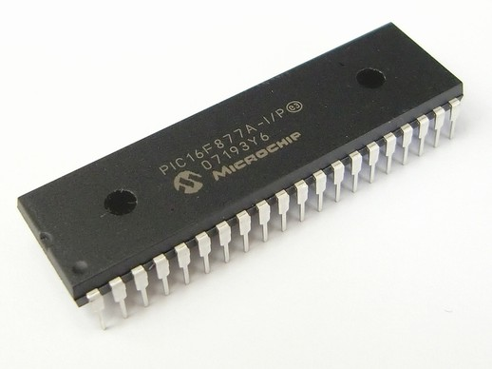](http://microcontrollerslab.com/wp-content/uploads/2015/08/PIC16F877A-microcontroller.jpg)

**Fig.4.5 pic IC pin**

PIC16f877a finds its applications in a huge number of devices. It is used in remote sensors, security and safety devices, home automation and in many industrial instruments. An[EEPROM](http://microcontrollerslab.com/eeprom-working-interfacing-with-microcontroller/) is also featured in it which makes it possible to store some of the information permanently like transmitter codes and receiver frequencies and some other related data. The cost of this controller is low and its handling is also easy. Its flexible and can be used in areas where microcontrollers have never been used before as in coprocessor applications and timer functions etc.

The microcontroller that has been used for this project is from PIC series. PIC microcontroller is the first RISC based microcontroller fabricated in CMOS (complementary metal oxide semiconductor) that uses separate bus for instruction and data allowing simultaneous access of program and data memory. The main advantage of CMOS and RISC combination is low power consumption resulting in a very small chip size with a small pin count. The main advantage of CMOS is that has immunity to noise than other fabrication techniques.

**4.4.1 PIC 16877A:**

Various microcontrollers offer different kinds of memories. EEPROM, EPROM, FLASH etc. are some of the memories of which FLASH is the most recently developed. Technology that is used in PIC 16877 is flash technology, so that data is retained even when the power is switched off. Easy programming and erasing are other features of PIC 16F877. PIC16F877A microcontroller is used in the project.

**4.4.2.CORE FEATURES**

|  |  |
| --- | --- |
| CPU | 8-bit PIC |
| Number of  Pins | 40 |
| Operating Voltage (V) | 2 to 5.5 V |
| Number of I/O pins | 33 |
| ADC Module | 8ch, 10-bit |
| Timer Module | 8-bit(2), 16-bit(1) |
| Comparators | 2 |
| DAC Module | Nil |
| Communication | UART(1), SPI(1), I2C(1), MSSP(SPI/I2C) |
| External Oscillator | Up to 20Mhz |
| Internal Oscillator | Nil |
| Program Memory Type | Flash |
| Program Memory (KB) | 14KB |
| CPU Speed (MIPS) | 5 MIPS |
| RAM Bytes | 368 |
| Data EEPROM | 256 bytes |

**Tab 4.6 features**

**4.4.3. PERIPHERAL FEATURES**

* Timer0: 8bit timer/counter with 8-bit prescaler
* Timer1: 16-bit timer/counter with prescaler, can be incremented during sleep via external clock/crystal
* Timer2: 8-bit timer/counter with 8-bit period register, prescaler and postscaler
* 10-bit multichannel Analog-to-Digital converter
* Synchronous Serial Port (SSP) with SPI (Master mode) and 12C (Master/ Slave)
* Universal Synchronous Asynchronous Receiver Transmitter (USART/SCI) with 9-bit address detection
* Brown – out detection circuitry for Brown out Reset (BOR)

**4.4.4. PIN DESCRIPTION**

PIC16F877A consists of 40 pins enclosed in 5 ports. Each port holds 8 pins which are bidirectional input/output pins. Pin diagram of PIC 16F877 is represented in Fig.

[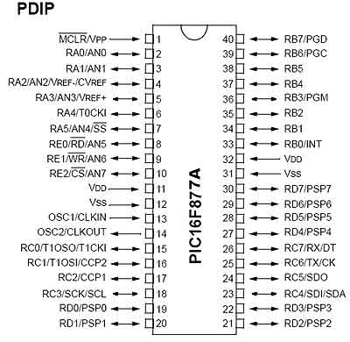](http://microcontrollerslab.com/wp-content/uploads/2015/08/PIC16F877A-Pin-configuration.jpg)

**Fig 4.7 Pin description**

**4.5. RELAY DRIVER**

A relay is an electro-magnetic switch which is useful if you want to use a low voltage circuit to switch on and off a light bulb (or anything else) connected to the 220v mains supply.

The current needed to operate the relay coil is more than can be supplied by most chips (op. amps etc), so a transistor is usually needed.

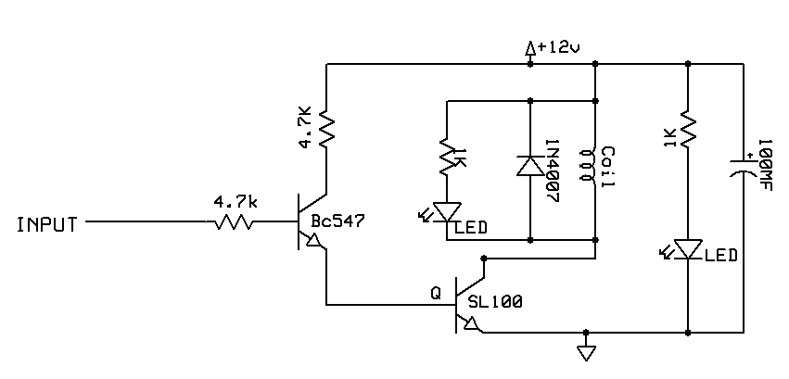

**Fig4.8 Circuit dig. of relay driver**

**4.5.1 RELAY**

A relay is an electro-magnetic switch which is useful if you want to use a low voltage circuit to switch on and off a light bulb (or anything else) connected to the 220v mains supply.

The diagram below shows a typical relay (with “normally-open” contacts).

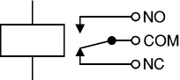

**Fig 4.9 relay**

The current needed to operate the relay coil is more than can be supplied by most chips (op. amps etc), so a transistor is usually needed.

The traditional form of a relay uses an electromagnet to close or open the contacts, but other operating principles have been invented, such as in solid-state relays which use semiconductor properties for control without relying on moving parts. Relays with calibrated operating characteristics and sometimes multiple operating coils are used to protect electrical circuits from overload or faults; in modern electric power systems these functions are performed by digital instruments still called protective relays.

|  |
| --- |
|  |

### 4.5.2. ULN2003 IC

The **ULN2003**is a 16-pin IC. **ULN2003 IC**is one of the most commonly used **Motor driver IC.** This IC comes in handy when we need to drive high current loads using digital logic circuits like Op-maps, Timers, Gates, Arduino, PIC, ARM etc.It has seven Darlington Pairs inside, where each can drive loads up to 50V and 500mA. For these seven Darlington Pairs we have seven Input and Output Pins. Adding to that we can a ground and Common pin. The ground pin, as usual is grounded and the usage of Common pin is optional. It might be surprising to note that this IC does not have any Vcc (power) pin; this is because the power required for the transistors to work will be drawn from the input pin itself.

**4.6. LAMP LOAD**

An incandescent light bulb, incandescent lamp or incandescent light globe is an electric light with a wire filament heated to such a high temperature that it glows with visible light (incandescence). The filament, heated by passing an electric current through it, is protected from oxidation and to a lesser degree, from evaporation with a glass or fused quartz bulb that is filled with inert gas or more rarely is evacuated of all gases, such as those found in air. In a halogen lamp filament evaporation is slowed by a chemical process that redeposits metal vapor onto the filament, thereby extending its life.

The light bulb is supplied with electric current by feed-through terminals or wires embedded in the glass. Most bulbs are used in a socket which provides mechanical support and electrical connections.

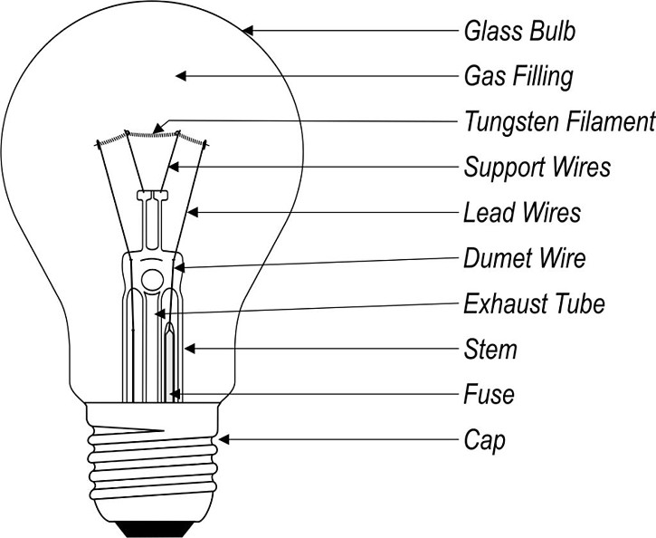

**Fig 4.10 Lamp load**

**4.7. IOT MODULE**

An IoT module is a small electronic device embedded in objects, machines and things that connect to wireless networks and sends and receives data. Sometimes referred to as a "radio chip" or "IoT chip", the IoT module contains the same technology and data circuits found in mobile phones but without features like a display or keypad.

Another key differentiator of IoT modules is that they provide **always-on** connectivity. This is because IoT applications need to send data automatically, in real-time without someone hitting a send button.

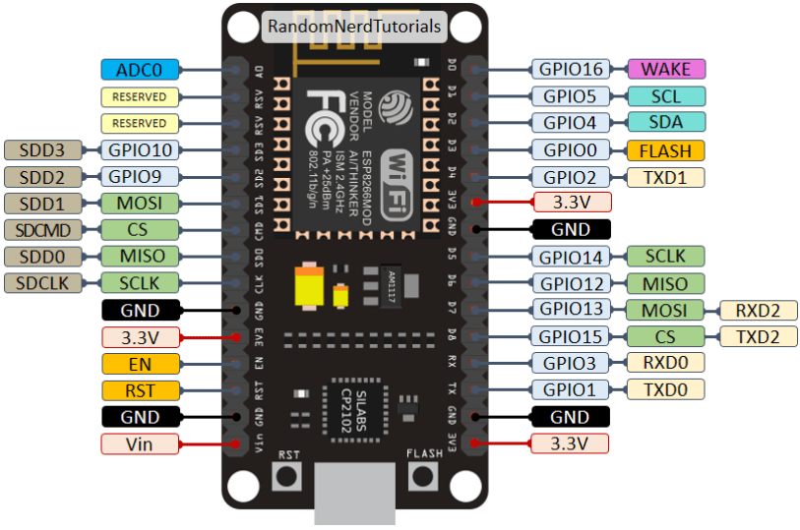

**Fig4.11 pin dig. of IOT module**

**4.7.1 PIN DESCRIPTION**

|  |  |
| --- | --- |
| **Name** | **Function** |
| VCC | Power 3.0 ~ 3.6V |
| GND | Ground |
| RESET | External reset signal (Low voltage level: Active) |
| ADC(TOUT) | ADC Pin Analog Input 0 ~ 1V |
| CH_PD | Chip Enable. High: On, chip works properly; Low: Off, small current |
| GPIO0(FLASH) | General purpose IO, If low while reset/power on takes chip into serial programming mode |
| GPIO1(TX) | General purpose IO and Serial TXd |
| GPIO3(RX) | General purpose IO and Serial RXd |
| GPIO4 | General purpose IO |
| GPIO5 | General purpose IO |
| GPIO12 | General purpose IO |
| GPIO13 | General purpose IO |
| GPIO14 | General purpose IO |
| GPIO15(HSPI_CS) | General purpose IO, Connect this pin to ground through 1KOhm resistor to boot from internal flash. |

**Tab 4.12 pin description of IOT module**

**4.8. LCD DISPLAY**

LCD display is used for displaying the continually monitored values from the sensors. All the sensor values will be displayed on the LCD. Based on that user can observe all the temperature, humidity and light intensity values. Without user involvement automatically controlling actions were performed whenever the present greenhouse values exceeds the user predefined values. In this project we use 16*2 LCD display. Based on our requirement we can select any type of LCDs.

LCDs are of two types:

1. Dynamic scattering type
2. Field effect type

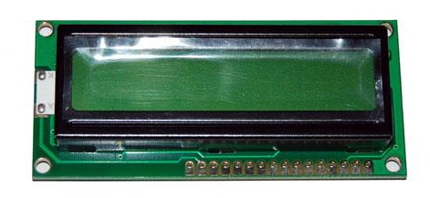

**Fig 4.13 Dig. of LCD display**

**4.8.1 PIN DESCRIPTION OF LCD**

|  |  |  |
| --- | --- | --- |
| PIN NO | SYMBOL | FUNCTION |
| 1 | Vss | Ground terminal of Module |
| 2 | Vdd | Supply terminal of Module, +  5v |
| 3 | Vo | Power supply for liquid crystal drive |
| 4 | RS | Register select  RS=0…Instruction register  RS=1…Data register |
| 5 | R/W | Read/Write  R/W=1…Read  R/W=0…Write |
| 6 | EN | Enable |
| 7-14 | DB0-DB7 | Bi-directional Data Bus.  Data Transfer is performed once ,thru DB0-DB7,incase of interface data length is 8-bits;and twice, thru DB4-DB7 in the case of interface data length is 4-bits.Upper four bits first then lower four bits. |
| 15 | LAMP-(L-) | LED or EL lamp power supply terminals |
| 16 | LAMP+(L+)  (E2) | Enable |

**Tab 4.14 pin description of lcd**

**4.8.2 LCD INTERFACING WITH MICROCONTROLLER:**



**Fig4.15 Circuit Diagram. of LCD interfacing with microcontroller**

**CHAPTER – 5**

**SOFTWARE DESCRIPTION**

**5.1 MPLAB IDE SOFTWARE**

**MPLAB** is a proprietary freeware integrated development environment for the development of embedded applications on PIC microcontrollers, and is developed by Microchip Technology.

MPLAB X is the latest edition of MPLAB and is developed on the [NetBeans](https://en.wikipedia.org/wiki/NetBeans) platform. MPLAB and MPLAB X support project management, code editing, debugging and programming of Microchip 8-bit, 16-bit and 32-bit PIC microcontrollers.

MPLAB is designed to work with MPLAB-certified devices such as the [MPLAB ICD 3](https://en.wikipedia.org/wiki/MPLAB_devices#MPLAB_ICD_3) and MPLAB REAL ICE, for programming and debugging PIC microcontrollers using a personal computer. PICK it programmers are also supported by MPLAB.

MPLAB 8.X is the last version of the legacy MPLAB IDE technology, custom built by [Microchip Technology](https://en.wikipedia.org/wiki/Microchip_Technology) in Microsoft [Visual C++](https://en.wikipedia.org/wiki/Visual_C%2B%2B). MPLAB supports project management, editing, debugging and programming of Microchip 8-bit, 16-bit and 32-bit Pic microcontrollers. MPLAB only works on [Microsoft Windows](https://en.wikipedia.org/wiki/Microsoft_Windows). MPLAB is still available from Microchip's archives but is not recommended for new projects.

MPLAB supports the following compilers:

* MPLAB MPASM Assembler
* MPLAB ASM30 Assembler
* MPLAB C Compiler for PIC18
* MPLAB C Compiler for PIC24 and dsPIC DSCs
* MPLAB C Compiler for PIC32
* HI-TECH C

MPLAB X is the latest version of the MPLAB IDE built by [Microchip Technology](https://en.wikipedia.org/wiki/Microchip_Technology), and is based on the open-source [NetBeans](https://en.wikipedia.org/wiki/NetBeans) platform. MPLAB X supports editing, debugging and programming of Microchip 8-bit, 16-bit and 32-bit [PIC](https://en.wikipedia.org/wiki/PIC_microcontroller) [microcontrollers](https://en.wikipedia.org/wiki/Microcontroller).

MPLAB X is the first version of the IDE to include cross-platform support for [Mac OS X](https://en.wikipedia.org/wiki/Mac_OS_X) and [Linux](https://en.wikipedia.org/wiki/Linux) operating systems, in addition to [Microsoft Windows](https://en.wikipedia.org/wiki/Microsoft_Windows).

MPLAB X supports the following compilers:

* MPLAB XC8 — C compiler for 8-bit PIC devices
* MPLAB XC16 — C compiler for 16-bit PIC devices
* MPLAB XC32 — C/[C++](https://en.wikipedia.org/wiki/C%2B%2B) compiler for 32-bit PIC devices
* HI-TECH C — C compiler for 8-bit PIC devices
* [SDCC](https://en.wikipedia.org/wiki/Small_Device_C_Compiler) — open-source C compiler

# HI-TECH C compiler for PIC10/12/16 MCUs (PRO)

**This compiler has been discontinued and is no longer supported.** This compiler has been replaced by the MPLAB® XC8 PRO (SW006021-2).  
HI-TECH C Compiler for PIC10/12/16 MCUs - PRO fully implements the optimizations of Omniscient Code Generation™ - a whole-program compilation technology - to provide denser code and better performance on PIC MCUs. This ANSI C compiler integrates into Microchips MPLAB(R) IDE and is compatible with Microchip debuggers and emulators.

**CHAPTER - 6**

**ADVANTAGES**

* IoT-Enabled Energy Monitoring: The integration of an IoT module allows for real-time monitoring of energy consumption by consumers through the IoT server. This enables efficient control of loads remotely.
* Government Regulation Compliance: By exempting the first 100 units of energy consumption from metering, the system aligns with government regulations. This ensures accurate calculation of electricity consumed in the consumer node, promoting transparency.
* Microcontroller Signal Analysis: The microcontroller's signal analysis capability enhances the accuracy of data sent to the LCD display, providing precise information on energy consumption in the consumer node.
* Wireless Energy Meter Monitoring: The wireless energy meter monitoring system minimizes difficulties associated with traditional wired setups, offering flexibility and ease of installation.
* Safety Features: The inclusion of a temperature sensor serves as a proactive measure to detect fire accidents. In the event of a fire, the system automatically trips the main supply and updates the cloud server, contributing to enhanced safety.

**APPLICATION**

* Residential Energy Management:Enables homeowners to monitor and control their energy consumption remotely.Promotes energy-efficient practices and helps reduce electricity bills.
* Industrial and Commercial Energy Monitoring:Provides industries and businesses with a comprehensive tool for monitoring and managing power consumption.Supports effective load management and optimization of energy usage.
* Smart Grid Integration:Contributes to the development of smart grid infrastructure by facilitating real-time monitoring and control of energy distribution.
* Government Utility Services:Supports utility companies in monitoring energy consumption patterns.Facilitates compliance with government regulations on exempted energy units and enhances billing accuracy.
* Fire Safety and Hazard Detection:Acts as a fire safety system by using temperature sensors to detect abnormal temperature increases.Automatically disconnects power in the event of a fire, preventing further hazards.
* Renewable Energy Integration:Ensures that the load remains within renewable source capacity, preventing damage and optimizing energy use from renewable sources.
* Data-Driven Decision-Making:Facilitates data collection and analysis for informed decision-making.Supports long-term energy planning and policy development.

**CHAPTER – 7**

**RESULTS AND DISCUSSION**

The integration of a microcontroller, energy meter, signal conditioning unit, potential transformer, temperature sensor, driver and relay circuit, and IoT module in the proposed system has yielded compelling results. Through rigorous testing, the system showcased high accuracy in energy measurement while adhering to government regulations by excluding the initial 100 units of energy consumption. Leveraging wireless technology, real-time monitoring by the Electricity Board was achieved, alongside remote control and flexibility for users via the IoT module. Safety measures were robustly addressed through the detection of fire accidents and monitoring of voltage abnormalities, ensuring swift incident response and safeguarding connected loads. Overall, the system's performance underscores its effectiveness in optimizing energy management, ensuring compliance, and enhancing safety in consumer nodes.

**CONCLUSION**

The proposed energy meter monitoring system represents a comprehensive and user-centric solution for effective energy management. The integration of real-time monitoring, and detailed reporting has provided users with the tools needed to actively engage in responsible energy consumption practices. The system's affordability and scalability contribute to its accessibility and potential for widespread adoption. By promoting sustainability, convenience, and security, the proposed system aligns with the evolving landscape of smart energy solutions. The positive results observed underscore the system's effectiveness in empowering users to monitor, manage, and optimize their electricity usage, thereby contributing to a more sustainable and efficient energy future.

**CHAPTER - 8**

**REFERENCES**

[1] H. G. Rodney Tan, C. H. Lee and V. H. Mork, “Automatic power meter reading systems using GSM network”, IEEE, 8th International Power Engineering Conference, pp. 465-469, 2007.

[2] Ashna K, Sudhish N Gorgre, “GSM based automatic energy meter reading system with instant billing”, IEEE, International conference held at Kottayam, pp. 65-72, 2013.

[3] Tian yew lim and tat Waichan,“Experimenting remote kilowatthour meter reading through low voltage power lines at dense housing estates”, IEEE Transactions on Power Delivery vol. 17, Issue 3, pp. 708-711, Jul 2002.

[4] M.Popa, “Gateway design and implementation in an automatic meter reading system based on power line communication”, 7th International Conference on Networked Computing and Advanced Information Management (NCM), pp. 295-298, 2011.

[5] Champ Prapasawad, Kittitachpornprasitpol, Wanchalermpora, -“Development of an automatic meter reading system based on ZigBee pro smart energy profile IEEE 802.15.4 standard”, International Conference on Electronic Devices and Solid State Circuit (EDSSC), pp. 1-3, Dec2012.

[6]SubhashisMaitra, “Embedded Energy Meter- A new concept to measure the energy consumed by a consumer and to pay the bill”, Power System Technology and IEEE Power India Conference, 2008.

[7] O.Homa Kesav and B.Abdul Rahim “Automated wireless Meter Reading System for Monitoring and Controlling Power Consumption”, International Journal of Recent Technology and Engineering, vol 1, no.2, june 2012.

[8] G. L. Prashanthi and K. V. Prasad,”Wireless power meter monitoring with power theft detection and intimation system using GSM and Zigbee networks”, Journal of Electronics and Commnication Engineering, vol.9, no.6, Nov-Dec. 2014.

[9] A. Abdollahi, M. Dehghani and N. Zamanzadeh, “SMS- sbased reconfigurable automatic meter reading system”, IEEE International Conference on control Applications ,PP.1103-1107,oct 2007.

[10] R. B Hiware, P.Bhaskar, Uttam Bombale and Nilesh Kumar, “Advance Low Cost Electricity Billing System using GSM”, Hiware etal international Journal of Advanced Engineering Technology E-ISSN 0976-3945.

[11] Guillaume Peersman and Srba Cvetkovic “The Global System for Mobile Communications Short Message Service”, IEEE personal Communications, PP. 15-23, Jun.2000.

[12] A. Arif, Muhannad AI-Hussain, Nawaf AI-Mutairi, “Experimental study and Design of smart Energy Meter for the smart Grid” , IEEE International Conference, pp 978-1-4673-6374, 2013.

[13] Liting Cao, Jingwen Tian and Dahang Zhang “Networked Remote Meter- Reading system Based on Wireless Communication Technology” IEEE International Conference on Information Acquisition, August20-23,2006.

[14] T. Chandler, “The technology development of automatic metering and monitoring systems,” in IEEE International Power Eng.Conference., Dec.2005.

[15] Mohd Yunus Nayan, Aryo Handoko Primicanta, Mohammad Awan “Hybrid Automatic Meter Reading System”, in IEEE International Conference on Computer Technology and Development 978-3892, July 2009